***DungeonOfDooom***: Requirements Document (version 1.0)

Project: DungeonofDooom

Due Date: 16.12.2016

1. Introduction

This document contains the system requirements for *DungeonofDooom*. These requirements have been derived from Moodle.

**Types of Reader**

Our readers are Senior Lecturer Julian Padget and Charlie Ann Page.

**Technical Background Required**

To understand code’s structure and development phases, readers should have knowledge on computer science.

1.1 Scope of the Product

To analyse, specify, design and implement a multi-player on-line game.

1.2 Overview of the Requirements Document

For the requirements a team was required. Test-driven development should be applied. Scrum meetings should be made every week. Agile development phases should be applied. For coding, application of MVC should be used. 3-tier architecture should be made. Mixed languages should be used for both client and server side.

1. General Description

This section will give the reader an overview of the project, including why it was conceived, what it will do when complete, and the types of people we expect will use it. We also list constraints that were faced during development and assumptions we made about how we would proceed.

There are functional requirements for project development.

Human players should select his/her component (bot or multiplayer). Map of the dungeon should be created with walls, passages and coins. Coins are the scores of the game. A dungeon can be

of arbitrary size. A dungeon should contain at least as much gold as is required to win, and at least one exit passage. Player’s or bot’s location(s) should be shown on the map visualization. Players should move with keys, pick up gold and looking to find about the current room and exit.

2.1 Product Team Perspective

Our team consists of 6 people.

2.2 Product Functions

Login and registration function should be applied. A database should be created for login and registration values. Player can move by key press functions in the dungeon. In the menu screen, users can select game type and levels, components with buttons. Score should be calculated by the coinscollected function and score should be shown in the score table section. Player’s location should be called from server and needed to be updated.

2.3 User Characteristics

According to customer meeting notes; target is everyone. It is an online game and it is not requiring any technical background, training or education.

2.4 General Constraints

Customer didn’t specify any specific languages. So in the sprint, team decided to use Java Code . For tile creation and parsing JSON is used. For interface applications html and JavaScript are applied. Eclipse platform is used. MVC is made with model, controller and view sections.

2.5 Assumptions and Dependencies

Finished product can be delivered over the internet. It requires administrator only for adding a new player. No need for specific skills to play the game. Project should be finished until 16 December 2016.

2.6 Project Budget

There is no specific budget according to customer meetings.

1. Specific Requirements

This section of the document lists specific requirements for *DungeonOfDooom*. Requirements are divided into the following sections:

1. User requirements. These are requirements written from the point of view of end users, usually expressed in narrative form.
2. System requirements. These are detailed specifications describing the functions the system must be capable of doing.
3. Interface requirements. These are requirements about the user interface, which may be expressed as a list, as a narrative, or as images of screen mock-ups.
   1. Functional Requirements
4. The user must log in to play the game.
   1. If the player is not registered to the game, he can register by giving a username, a password and an email.
5. The user chooses options from a menu (single, multiplayer, score or tutorial)
   1. If player selects single player game, he enters the level selection screen.
   2. If player selects multiplayer game, he enters the level selection screen.
   3. If player selects score, he sees the scoreboards.
   4. If player selects tutorial, the player sees the instructions of the game.
   5. If player selects exit or closes the tab, the connection with server terminates.
6. The world is loaded on the server’s memory.
7. The player can see a part of the dungeon (explored tiles), other players (human or bots), gold coins, passages and exit.
   1. A dungeon is a collection of rooms that are connected with passages.
      1. A room may have gold coins.
   2. A dungeon can be arbitrary size.
   3. Dungeon must contain the minimum gold coins so the player can win.
8. Player interacts with the dungeon:
   1. Indicating which way to move (UP, DOWN, LEFT, RIGHT)
   2. Picking up gold.
   3. Player can move around to reveal the room.
   4. Leaving the game.
9. Winning Condition:
   1. If the player collects all the gold coins, needed to win, and find the exit, player wins.
   2. Else if another player wins first or the player gives up, the player loses.
10. After winning condition, the player goes to result screen.

3.2 Non-Functional Requirements

1. System consists of 3 components: Presentation layer, Business Logic Layer and Database Layer
   1. Database Layer have a MySQL database that contains information about players and score table (server side).
   2. Business Logic Layer contains Web services and Models of game’s components. These components will be written in Java (server side).
   3. Presentation Layer contains GUI(view) for the user and controllers that interact with the server via Web services. These components will be written in HTML5 & CSS3 and JavaScript (client side).

3.3 Use Cases

1. Use Case 1 – Log in

UC1-1: Use Case: Log In

UC1-2: Author: QZ, XF

UC1-3: Date: 8-NOV-2016

UC1-4: Purpose: Log in to the play the game

UC1-5: Overview: Starts when the player opens the game page. System requests username and password for login. System validates username and password (if the username and password already exists in the player database) then player enters the Main Menu Screen, else alternative 1: Validation fails and log in failure message is given to the user.

UC1-6: Cross References: R1

UC1-7: Actors: Player

UC1-8: Pre-Condition:

UC1-Pre-1: The website must be loaded.

UC1-9: Post Condition:

UC1-Post-1: The player is prompted to Main Menu screen.

|  |  |  |
| --- | --- | --- |
| Actor Actions | Client System Actions | Server System Actions |
| 1. Open the game page. |  |  |
| 1. Input the username and password. |  |  |
| 1. Press “OK” button. |  |  |
|  | 1. Sends the username and password to server. |  |
|  |  | 1. Check if the username already exists in the membership database and validates the password. |
|  |  | 1. Sends response. |
|  | 1. Receives and parses the response. |  |
|  | 1. Jump to the main menu interface. |  |

UC1-10: Alternative flow of events:

* + Step 5: Username and password is not in the player database. Display an error message, and ask player to reenter their credentials.

UC1-11: Exceptional flow of events:

* Steps 4, ,6, 7: If the connection with the server is not established return an error message.

1. Use Case 2 – Registration

UC2-1: Registration

UC2-2: Author: AG

UC2-3: Data: 27-NOV-2016

UC2-4: Purpose: Player registers to the game

UC2-5: Overview: The user fills a form with his desired username, his email address and his desired password. If the username or email does not exist on the system’s database, then the system saves these details and returns to log in screen. Else, alternative 1: if username or email exists in database, then an appropriate message is returned to the user and the user must pick a different username or email. Alternative 2: if the email does not contain “@” and “.” characters the client must give an appropriate message.

UC2-6: Cross Reference: R1.1, R1

UC2-7: Actors: Player

UC2-8: Pre-Conditions:

UC2-Pre-1: The registration web page must be loaded.

UC2-Pre-2: The player must not have an account.

UC2-9: Post-Conditions:

UC2-Post-1: The player returns to log in screen.

UC2-Post-2: The player’s information is stored into the server’s database.

|  |  |  |
| --- | --- | --- |
| Actor Actions | Client System Actions | Server System Actions |
| 1. Open the registration page. |  |  |
| 1. Input the username, the email and the password. |  |  |
| 1. Press “OK” button. |  |  |
|  | 1. Sends the username, the email and password to server. |  |
|  |  | 1. Stores the username, the email and the password to system’s database. |
|  |  | 1. Sends response. |
|  | 1. Receives and parses the response. |  |
|  | 1. Jump to the log in page. |  |

UC2-10: Alternative flow of events:

* Step 5: Username or email already exists on the system’s database. Appropriate message is returned to the player so the player can pick different username or email.

UC2-11: Exceptional flow of events:

* Step 4, 6, 7: If the connection with the server is not established return an error message.

1. Use Case 3 – Main Menu

UC3-1 Use Case: Player Choose Menu

UC3-2 Author: XF, QZ

UC3-3: Date: 8-NOV-16

UC3-4: Purpose: The user chooses options from the main menu.

UC3-5: Overview: The player is logged in and is prompted to main menu. There are four button: single player game, multiplayer game, score and tutorial. If the player selects single player game or multiplayer game, then he is prompted to level selection screen. The player must select a match level he wants to play in, the client sends a request to server and the server sends dungeon data to the client. The user is prompted into the dungeon map and starts playing the game. Else, alternative 1: if the player selects score, the game client sends a request to the server to retrieve the score table from the database. The server sends the data back to client. Else, alternative 2: if the player selects tutorial, them he is prompted to tutorial screen. Else, alternative 3: if the player selects the exit button, the player logs out of the system and returns to log in screen.

UC3-6: Cross References: R2, R2.1, R2.2, R2.3, R2.4, R2.5

UC3-7: Actors: Player

UC3-8: Pre-Condition:

UC3-Pre-1: The player must be in menu (i.e. not the dungeon).

UC3-Pre-2: The player must already be logged in.

UC3-9: Post Condition:

UC3-Post-1: The player is sent to appropriate web page based on his/her action.

Single/Multiplayer button

|  |  |  |
| --- | --- | --- |
| **Actor Actions** | **Client System Actions** | **Server System Actions** |
| 1. Begins when player click single player of multiplayer button |  |  |
|  | 1. Sends button request to the server |  |
|  |  | 1. The server initiates the player’s session. |
|  | 1. Jumps to level selection web page. |  |
| 1. The user selects a match to play in. |  |  |
|  | 1. The client sends a request to the server |  |
|  |  | 1. The server responds with dungeon data. |
|  | 1. Client receives the response and creates a graphical representation of the data. |  |

Score button

|  |  |  |
| --- | --- | --- |
| **Actor Actions** | **Client System Actions** | **Server System Actions** |
| 1. Begins when player click score button |  |  |
|  | 1. Sends button request to server |  |
|  |  | 1. Retrieve the scoreboard from database. |
|  | 1. The user is prompted to score table web page and shows the data. | 1. Send response |

Tutorial

|  |  |  |
| --- | --- | --- |
| **Actor Actions** | **Client System Actions** | **Server System Actions** |
| 1. Begins when player click Tutorial button |  |  |
|  | 1. The user is prompted to tutorial page. |  |

UC3-9: Alternative flow of events:

UC3-10: Exception flow of events:

* In steps where the client sends a request or the server sends a response, if the client does not receive any response in time, appropriate message should be displayed.

1. Use Case 4 – World Creation

UC4-1 Use Case: World Creation

UC4-2 Author: SK

UC4-3: Date: 13-NOV-16

UC4-4: Purpose: To create map, dungeon, coins, passages

UC4-5: Overview: After the match selection, dungeon is created. The client sends a request to server to retrieve graphical representation of the dungeon. Dungeon consists of rooms. Rooms are connected with each other with passages. Rooms must contain gold coins. Rooms can be of arbitrary size. Dungeon must contain minimum gold coins for win condition.

UC4-6: Cross Reference: R3, R4, R4.1, R4.2, R4.3

UC4-7: Actors: Player

UC4-8: Pre-Condition:

UC4-Pre-1: The player must select a match.

UC4-Pre-2: The player must already log on.

UC4-9: Post Condition:

UC4-Post-1: Player enters the game map and sees a graphical representation of the dungeon.

|  |  |  |
| --- | --- | --- |
| **Actor Actions** | **Client System Actions** | **Server System Actions** |
| 1. Begins when player selects a match. |  |  |
|  | 1. Sends button request to server |  |
|  |  | 1. Dungeon is created with rooms, passages and coins. Server saves this information on its memory. |
|  |  | 1. Sends response with visible area by the player |
|  | 1. Receives and parses response |  |
|  | 1. The client draws the graphical representation of the dungeon. |  |

1. Use Case 5 - Movement

UC5-1 Use Case: Player Moves Character

UC5-2 Author: AG, MJ

UC5-3: Date: 8-NOV-16

UC5-4: Purpose: Move the player in one of the four directions

UC5-5: Overview: The player character’s location is a particular point on the map. The Player presses one of the keys W, A, S or D. These keys map to up, left, down, right respectively. The game client sends a request to the server with the details on the action. The server validates this input and decides whether or not the player character can move in that direction. If the character can be moved the server updates the character’s position in-memory. The server responds with the current location of the character. The client updates the dungeon graphical representation. Alternative 1: A wall is blocking the direction that the player wishes to move their character in. The server does not update the player’s position and responds with the current player location the same as it was.

UC5-6: Cross References: R5, R5.1

UC5-7: Actors: Player

UC5-8: Pre-Condition:

UC5-Pre-1: The player must be in a dungeon (i.e. not the menu).

UC5-Pre-2: The map has been loaded.

UC5-9: Post Condition:

UC5-Post-1: The player’s position is the player’s previous position moved one unit in the chosen direction.

UC5-Post-2: The client’s graphical representation has updated.6

|  |  |  |
| --- | --- | --- |
| **Actor Actions** | **Client System Actions** | **Server System Actions** |
| 1. Begins when player presses movement key |  |  |
|  | 1. Sends movement request to server |  |
|  |  | 1. Checks whether or not the player can move in that direction. |
|  |  | 1. Sends response |
|  | 1. Receives and parses response |  |
|  | 1. Updates dungeon graphical representation |  |

UC5-10: Alternative flow of events:

Step 3: The movement is illegal. Server doesn’t update player location, responds with player in the same location.

UC5-11: Exception flow of events:

Steps 2,4,5: The request or response network packets are dropped or corrupted. The sends a request for the current state of the system. If that request fails, the client displays an appropriate message regarding network connectivity problems to the player.

1. Use Case 6 - Coins

UC6-1: Use Case: Picking up Gold coins

UC6-2: Authors: AG, MJ

UC6-3: Date: 8-NOV-16

UC6-4: Purpose: Moves to gold coin to collect it.

UC6-5: Overview: The player moves to a tile with a gold coin on it. The server responds that the gold coin in no longer in its previous position, it increments player’s gold coin collection and moves the player to the location of the coin. The client updates the dungeon graphical representation.

UC6-6: Cross References: R5, R5.2

UC6-7: Actors: Player

UC6-8: Pre-condition:

UC-6-Pre-1: The player must be in a dungeon (i.e. not in the menu)

UC-6-Pre-2: The player should be one unit away from the gold coin.

UC6-9: Post-condition:

UC-6-Post-1: The player’s gold coin collection is incremented.

UC-6-Post-2: The player moves to the updated location.

UC-6-Post-3: The client updates the dungeon graphical representation.

|  |  |  |
| --- | --- | --- |
| **Actor Actions** | **Client System Actions** | **Server System Actions** |
| 1. Player begins to move to a gold coin. |  |  |
|  | 1. The client sends a request to the server. |  |
|  |  | 1. The server receives the request. |
|  |  | 1. The server validates the action. |
|  |  | 1. The server increments player’s gold coin collection. 2. The server updates gold coin location. 3. Sends response |
|  | 1. Receives and parses the response 2. Updates the graphical representation. |  |
|  |  |  |

UC6-11: Exceptional flow of events:

* Same as UC5-11

1. Use Case 7 – Map visibility

UC7-1 Use Case: Player movement reveals the map

UC7-2 Author: AG, MJ

UC7-3: Date: 8-NOV-16

UC7-4: Purpose: To discover the layout the dungeon

UC7-5: Overview: The player character is moving from one tile to another. The Server decides which tiles are visible to the player character. The server response includes the current state of the tiles now visible to the player character. The client adds these tile states to its memory. The client remains aware of previously discovered tiles but may not be aware of their current state, i.e. whether another player has moved their character to that location. The client updates the graphical representation including the newly visible tiles.

UC7-6: Cross References: R5, R5.3

UC7-7: Actors: Player

UC7-8: Pre-Condition:

UC7-Pre-1: The player must be in a dungeon (i.e. not the menu)

UC7-Pre-2: The player is in a state of moving from one tile to the next

UC7-9: Post Condition:

UC7-Post-1: The client updates its memory with new tile states.

UC7-Post-2: The client now displays additional tiles that may not have been previously visible.

|  |  |  |
| --- | --- | --- |
| **Actor Actions** | **Client System Actions** | **Server System Actions** |
|  |  | 1. Begins when the server interprets a move command |
|  |  | 1. Decides which tiles are visible to the character |
|  |  | 1. Responds to move request, including the current state of tiles now visible to the player character |
|  | 1. Receives and parses the response |  |
|  | 1. Adds the updated and/or new tiles to its memory |  |
|  | 1. Updates the graphical representation |  |

UC7-11 Exceptional flow of events:

* Same as UC5-11

1. Use Case 8 - Exit

UC8-1: Use Case: Leaving the Game

UC8-2: Authors: AG, MJ

UC8-3: Date: 8-NOV-16

UC8-4: Purpose: To exit the game.

UC8-5: Overview: The player presses a button to return to the main menu. The client sends a request to server to terminate the session. The server removes the player’s character.

UC8-6: Cross References: R5, R5.4

UC8-7: Actors: Player

UC8-8: Pre-condition:

UC-8-Pre-1: The player must be in a dungeon (i.e. not in the menu)

UC-8-Pre-2: The player presses the exit button

UC8-9: Post-condition:

UC-8-Post-1: The player returns to main menu

UC-8-Post-2: The server removes the player from the game.

|  |  |  |
| --- | --- | --- |
| **Actor Actions** | **Client System Actions** | **Server System Actions** |
| 1. The player presses the exit button. |  |  |
|  | 1. Sends request to the server. |  |
|  |  | 1. Receives the request. |
|  |  | 1. Removes the player’s character. |
|  | 1. Returns to main menu. |  |

UC8-11: Exception flow of events:

* Step1: The player closes the browser to exit the game. The server notices that the client has not sent any request within a time limit and removes the player’s character.
* Step 2: Same as UC5-11

1. Use Case 9 – Winning Condition

UC9-1: Use Case: Winning condition

UC9-2: Authors: AN

UC9-3: Date: 9-NOV-16

UC9-4: Purpose: To show the winning status and Main map with unlocked level.

UC9-5: Overview: The player won the game by passing through exit. The client sends the request to update the score. Server starts processing request. Server updates the results in scoreboard, unlock the new level and sends a response back to client to show the result screen with details which include time, coins or other entities player collected. Followed by client displays the main map to player, which shows the unlocked level with an option to return to main menu. Else alternative 1: another player exits the game first; the player returns to results screen with a “You lose” message.

UC9-6: Cross References: R6, R6.1, R6.2, R7

UC9-7: Actors: Player

UC9-8: Pre-condition:

UC-9-Pre-1: The player must be in dungeon and pass through exit.

UC-9-Pre-2: The player must win the game (player must collect the minimum amount of coins.

UC9-9: Post-condition:

UC-9-Post-1: The player gets the result screen.

UC-9-Post-2: The server updates the scoreboard & sent the result screen.

|  |  |  |
| --- | --- | --- |
| **Actor Actions** | **Client System Actions** | **Server System Actions** |
| 1. The player won the game. |  |  |
|  | 1. Sends the updated result to the server. |  |
|  |  | 1. Receives the request. |
|  |  | 1. Update the scoreboard. 2. Unlock a new level 3. Sends the result screen. |
|  | 1. Shows the result screen 2. Shows the main map with unlocked level 3. Returns to main menu. |  |

UC9-11: Exception flow of events:

* Step1: If player loses the connection to the network after winning the game, client wait for a specified amount of time. If player comes back, client sends request to server and steps 2-8 will carry on. If the server hasn’t got any request within the time limit, then server will remove the player’s character.

1. System Architecture

4.1 THREE-TIER ARCHITECTURE

The online multiplayer will be implement by three-tier client–server architecture model. Three-tier architecture allows any one of the three tiers to be upgraded or replaced independently. The user interface is implemented on a desktop PC, which is client side of multiplayer game and uses a standard graphical user interface with different modules running on the application server. The relational database management system on the database server contains the computer data storage logic, which is implemented using json and msql.

The three tiers in a three-tier architecture are:

* Presentation Tier: It includes the top level and presents the information related to services available on client side. This tier sends data to other tiers to communicate. For eg: sending result of game to database. All communication with the Presentation layer is done through Web Services.
* Application Tier: Also called the logic tier or business logic, this tier is responsible for controlling application functionality by performing detailed processing.
* Data Tier: Houses database servers where information is stored and retrieved. The Data Layer provides persistence for the system and all communication is done through SQL queries and views. Data in this tier is kept independent of application servers or business logic. For eg: storing score, storing records of players

4.2 DESIGN PATTERN

The design pattern associate with our multiplayer game is MVC (Model View Controller) design pattern. The MVC design pattern clearly separated the web application’s behaviour, presentation and control. The modularity of this design pattern allows for easier code reuse, more centralized control, bugs easier to track down and code easier to modify. The client will be running on presentation layer. The presentation, or view, of the multiplayer game will be implemented in HTML, CSS and Javascript. The database layer includes json files and mysql.

The business tier includes the model classes of multiplayer game.

Apart from that, the system needs to satisfy any functional, non-functional or aesthetic needs in a software system. The Dungeon of Doom follows the three-tier architectural style, which includes presentation tier, business tier, and data tier. The following is a simple description of what will be included in each of the tiers:

Presentation Tier

Data Tier

Business Tier

* Presentation Tier: used to present the information to the player.
* Business Tier: used to implement the logic of the system
* Data Tier: To storing the data and other external services that the system may use.

1. 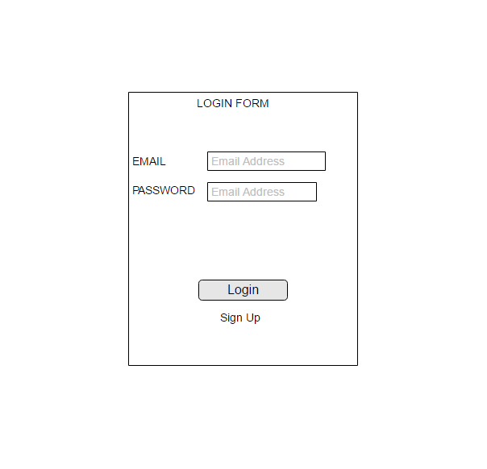Interface Requirements

5.1 Login Form

5.2 Sign Up Form

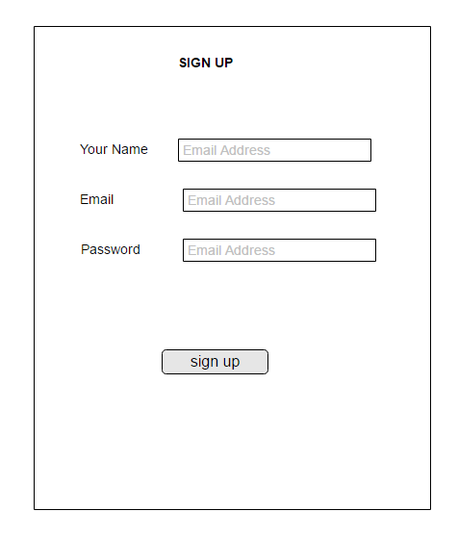

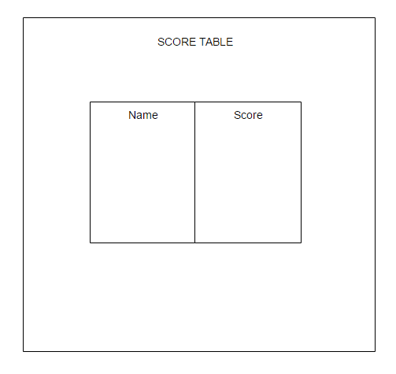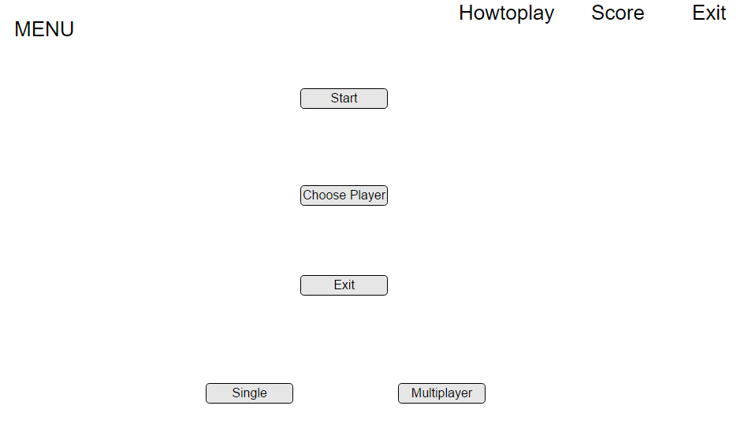

* 1. Menu

5.4 Score Table

1. CRC Cards

|  |  |
| --- | --- |
| Player | |
| Username  Password  Level  Type | Character  score |

|  |  |
| --- | --- |
| Score table | |
| Score  Calculate  Max  Id(time-stamp) | player |

|  |  |
| --- | --- |
| Level | |
| Load from file | Dungeon  Match  Coins |

|  |  |
| --- | --- |
| Dungeon | |
| Size  Name  Number of coins | Character  File  level |

|  |  |
| --- | --- |
| Character | |
| Position  Gold coins collected  Movement  Track collected coins | Player  score |

|  |  |
| --- | --- |
| Tile | |
| Type  visibility | Dungeon |

|  |  |
| --- | --- |
| Match | |
| Check  Victory  Condition | Score |

1. UML

7.1 Client-side

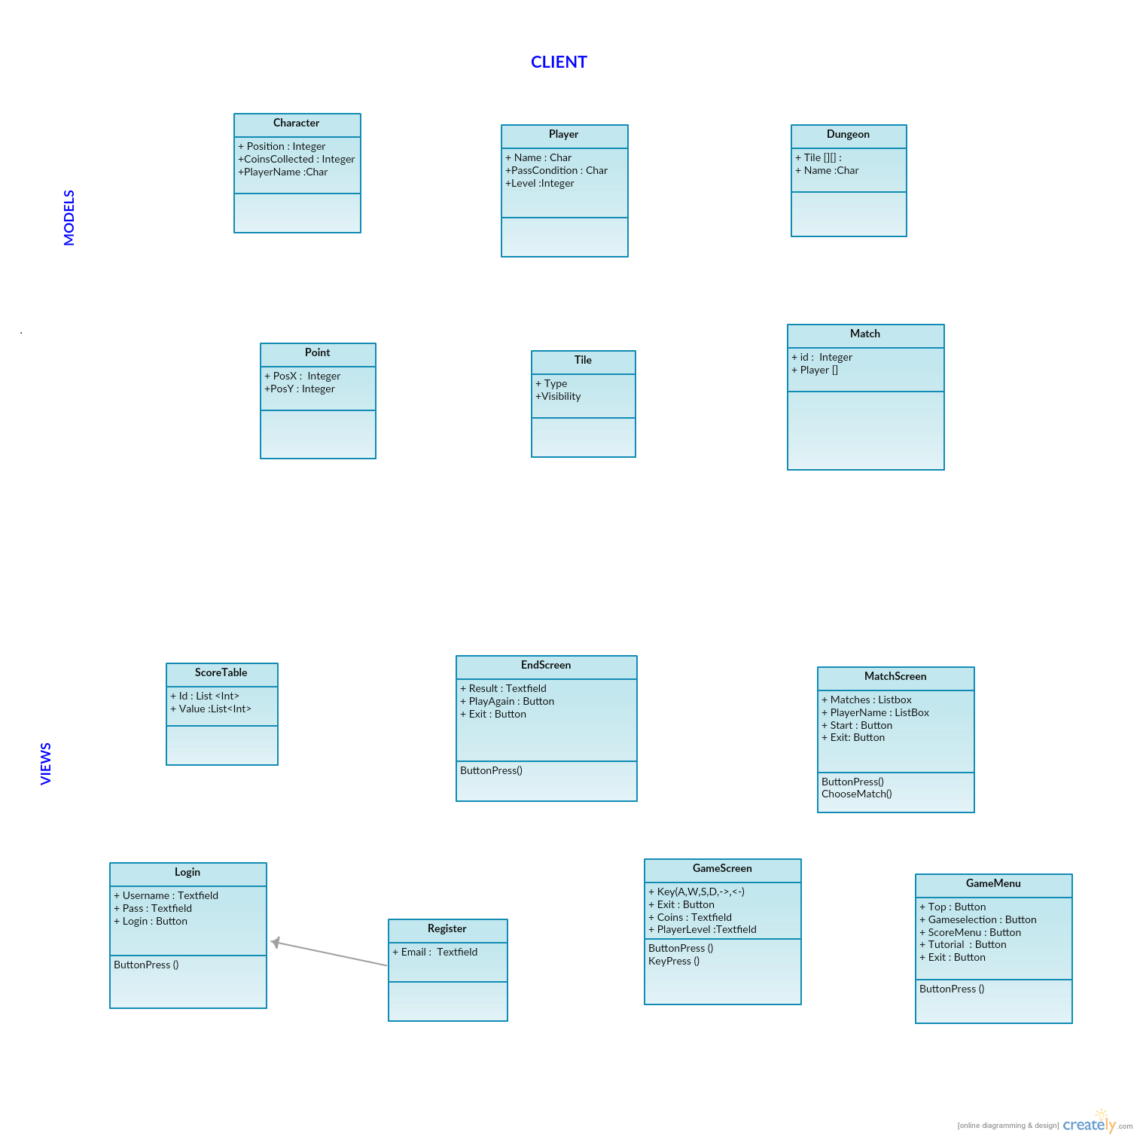

7.2 Server-side Controllers

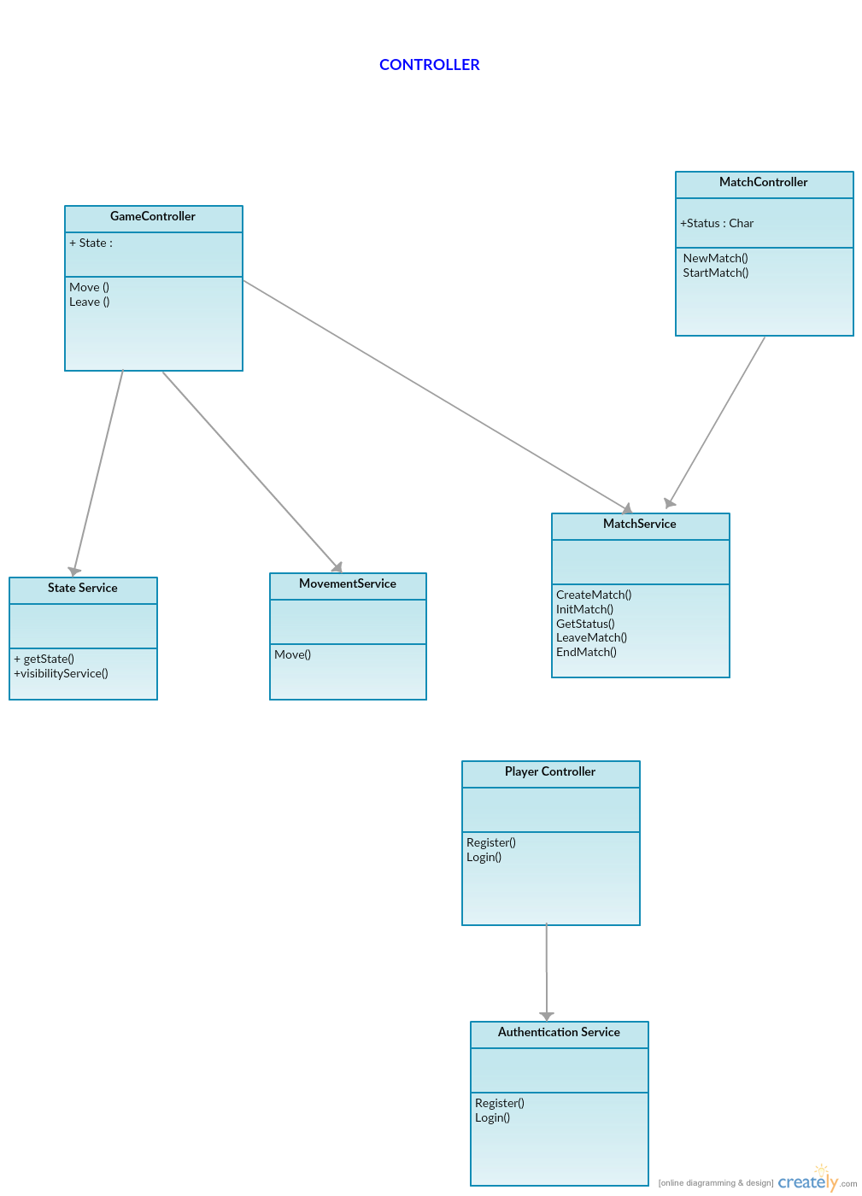

7.3 Server-Side Models & Database

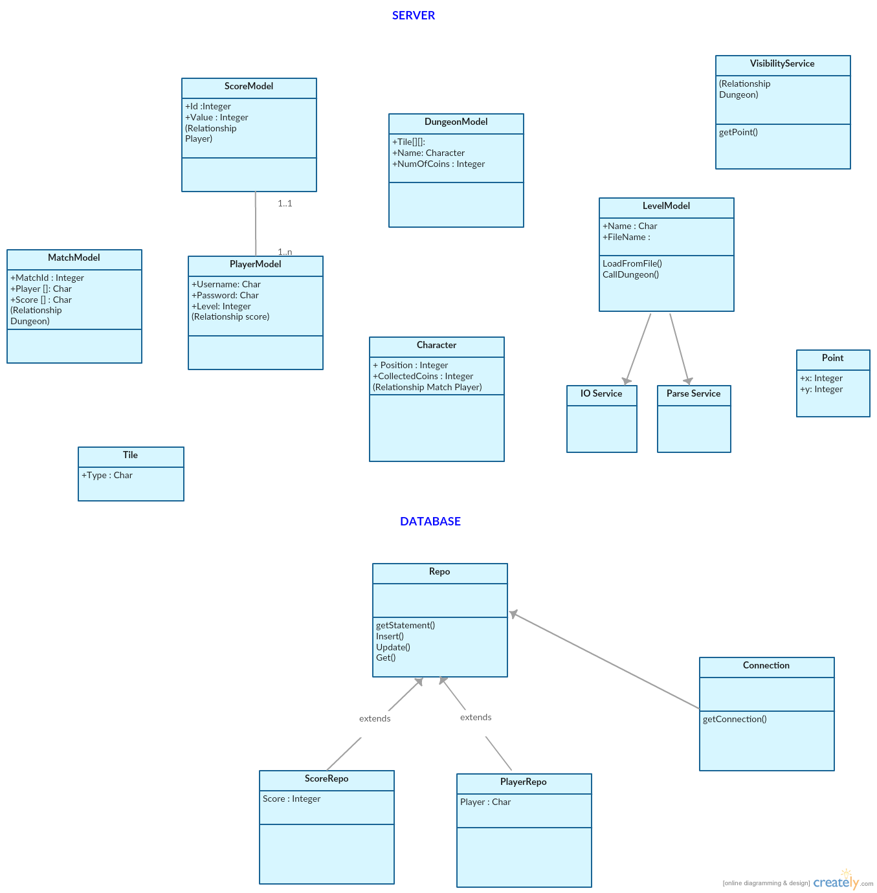

1. Test Plan

8.1 Introduction

Testing is a crucial part of designing a software system. Testing enables us to make a clear concise design decisions early in development and by providing tests that match these designs ensures that if these design decisions are changed, appropriate attention and fair warning will be given to their impact. Kaner (2006) suggests that tests should not be absolute and final but should start off simply and evolve over time with the system. In line with this we aim to start with few, basic tests and add new tests as we add new features via Test Driven Development.

In this sense, we are closer to using Exploratory Testing rather than Automated Testing- that is, the responsibility for running tests belongs with the developer and not an automated system. We must vigilantly run tests ourselves.

We intend to test the system using Unit and Integration Tests, both Black-Box and White-Box, including boundary cases. Unit Testing will likely necessitate that we use stubs and build our system in a component-oriented or modular way (ISTQB Exam Certification, n.d.).

8.2 Test-Driven Development

We will follow test-driven development, writing interfaces or stubs of our components first and tests for those unimplemented components.

8.3 Tests

|  |  |  |  |  |
| --- | --- | --- | --- | --- |
| **Test name** | **Component being tested** | **Input** | **Expected output** | **Purpose** |
| ShouldConnectToDatabase | DatabaseConnection | n/a | An open database connection | Can generate a database connection |
| ShouldCloseDatabase | DatabaseConnection | n/a |  | Can close a generated connection |

1. References

ISTQB Exam Certification. (n.d.). What is Component testing? Retrieved 11 26, 2016, from ISTQB Exam Certification: http://istqbexamcertification.com/what-is-component-testing/

Kaner, C. (2006, Novemer 17). Exploratory Testing from Florida Institute of Technology, Quality Assurance Institute Worldwide Annual Software Testing Conference, Orlando, FL. Retrieved from Kaner.com: http://www.kaner.com/pdfs/ETatQAI.pdf